Yashkumar Patel

Q1:





Q2:





Q3:

1

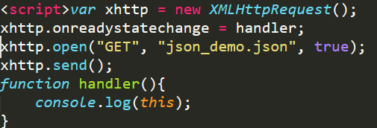  
This script is calling xhttprquest the on ready state it calls handler method and opens json_demo.json and console.log takes whole XMLHttpRequest Object as an input.

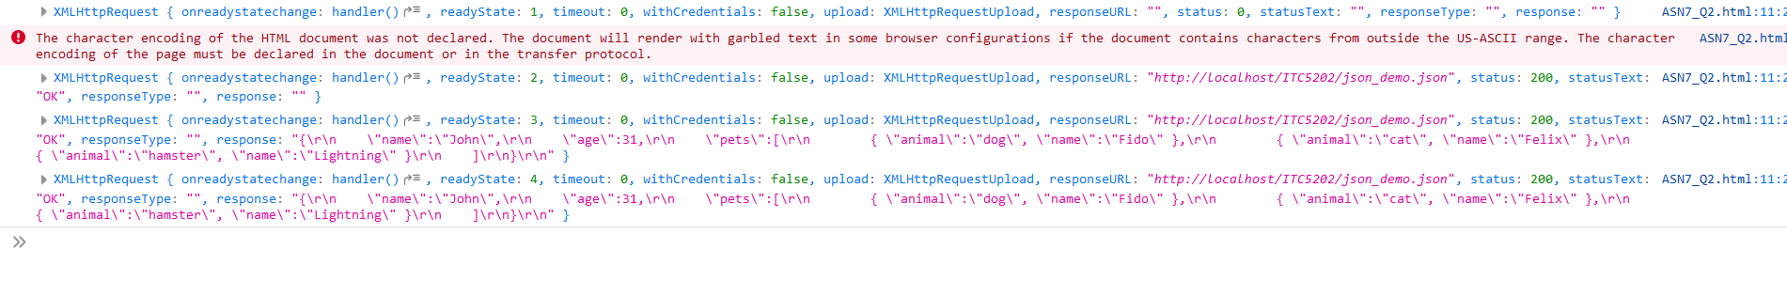

Here as we can see Console.log takes XMLHttpRequest objects as an input and printing in the console.

2.

This refers to the output of the XMLhttpRequest data.

3.

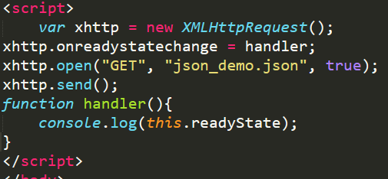

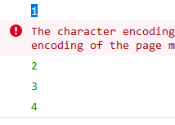

When we change this to this.readyState so output changes to object of XMLHttpRequest readyState.

4.

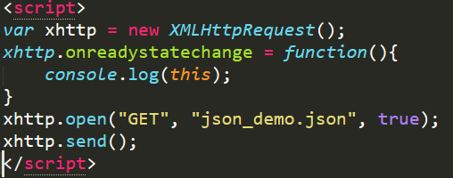

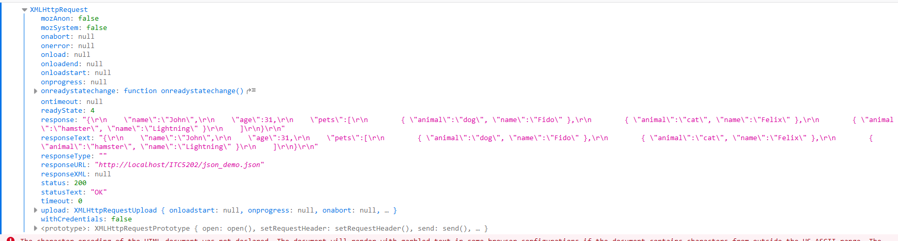

Both Scripts are giving same output but in first script we are calling one stand alone function handler in second script runs function without name.